**Image Analysis of the Tumor Microenvironment**

*Lloyd MC1,3, Johnson JO1, Kasprzak A1 and Bui MM1,2*

**Abstract**

In the field of pathology it is clear that molecular genomics and digital imaging represent two promising future directions, and both are as relevant to the tumor microenvironment as they are to the tumor itself [Beck 2012]. Digital imaging, or whole slide imaging (WSI), of glass histology slides facilitates a number of value-added competencies which were not previously possible with the traditional analog review of these slides under a microscope by a pathologist. As an important tool for investigational research, digital pathology can leverage the quantification and reproducibility offered by image analysis to add value to the pathology field. This chapter will focus on the application of image analysis to investigate the tumor microenvironment and how quantitative investigation can provide deeper insight into our understanding of the tumor to tumor microenvironment relationship.

**______________________________________________________________________________**

1Analytic Microscopy Core, 2Department of Anatomic Pathology, H. Lee Moffitt Cancer Center and Research Institute, 12902 Magnolia Dr., Tampa, FL, 33612; 3Department of Biological Sciences, University of Chicago Illinois, 845 W. Taylor St., Chicago, IL 60607

[Mlloyd8@uic.edu](mailto:Mlloyd8@uic.edu); [Marilyn.Bui@moffitt.org](mailto:Marilyn.Bui@moffitt.org); [Kasia.Rejniak@moffitt.org](mailto:Kasia.Rejniak@moffitt.org)

1. **Introduction**

Before the use of image analysis investigators have been able to observe changes in the tumor microenvironment and infer how these changes may effect tumor growth, progression or the effects of specific therapies [Kenny 2007; Dvorak 2011]. The tumor microenvironment describes the non-neoplastic cells and stroma present in the tumor. These include fibroblasts, blood vessels and the immune cells (Sugimoto 2006; Nyberg 2007; Song 2014). Instances specific to breast cancer, for example, may include the number of inflammatory cells, the thickness of the basement member of ducts, the ‘reactivity’ of stroma or other observations [Li 2007; Estrella 2013]. Unfortunately these associations are difficult to repeat reliably and therefore, have never largely been made part of a clinical standard for staging, grading or otherwise evaluating cancers. This is due, in part, to inter- and intra-observer variability [Robertson 1989; Karabulut 1995; Glatz 2007].

Image analysis is a tool which may be used to extract meaningful information from a digital image [Serra 1982]. Given the fact that image analysis is processed and reported by a computer, it is typically highly reproducible and objective. The results are no longer qualitative records observed by a human investigator but rather a quantified mathematical value which can be mined. Examples may include the number of objects, values or intensity of colors, or even patterns including the distribution of objects like vessels or ectopic lymph nodes [Messina 2012]. These are relatively simple examples and far more multifaceted analysis are possible with modern image analysis tools including content based image retrieval, pattern recognition, computer learning and deep learning, to name a few. In fact, pathologists are often the users who train the algorithms regarding what and how to identify specific regions of interest. It is critical that pathologists are involved in this process to ensure accurate identification of each region and for the quality control of what the algorithm is classifying.

The use of image analysis technologies for a more standardized and repeatable measurement of biological processes in tissue samples has become increasingly popular [Rojo 2010]. Computers are consistent and dependable for quantification of samples, for example, algorithms may be used for counting, searching large numbers of records or areas [Gurcan 2009; Mavaddat 2010]. Examples include FDA approved algorithms for counting positively stained immunohistochemical slides (e.g. ER, PR or HER2) [Lloyd 2010] or searching for rare events such as cytology abnormalities (e.g. Pap smear testing) [Deepak 2015].

While image analysis using these computer algorithms can help us quantify some aspects of a histological section they are not capable of performing the detailed and intricate diagnosis as it is rendered by a pathologist. Thus the benefit of a computer algorithm is best used in conjunction with a pathologist and this relationship can help us better understand new aspects of oncology and pathology which remain currently unknown. A prime example of leveraging image analysis for pathology diagnosis may in fact be the investigation of the tumor microenvironment and its role in understanding and treating cancer [Beck 2012].

This chapter will focus on three examples of imaging modalities for interrogating the tumor microenvironment and will use specific use cases.

1. **Imaging the Tumor Microenvironment**

Image analysis may be used on various types of images to analyze the involvement of the tumor microenvironment in a specific disease. In fact, the types of images which may be acquired and studied are quite vast, including radiology, endoscopy and other imaging modalities [McInerney 2006; Ohashi 2005]. For the purposes of this chapter the authors have chosen to exclusively discuss histological sections of pathology samples. This allows the authors to use ‘real-world’ examples which will then result in quantifiable to design in vitro, intravital, mathematical modeling experiments [Anderson 2007].

Additionally, the authors have chosen to focus on the most ubiquitous and available image acquisition modalities for the investigation of histological samples including 1) brightfield microscopy including hematoxylin and eosin, as well as immunohistochemically stained samples [Gurcan 2009; Lloyd 2010]; 2) fluorescent microscopy stained samples [Mass 2005]; and 3) Second Harmonic Generation [Amat-Roldan 2010]. Many additional image acquisition methods exist however the authors chose the rather diverse set of three methods listed above in order to demonstrate broad differences in the images available for image analysis of the tumor microenvironment as well as the types of information which may be gleaned regarding how the tumor microenvironment may be studied.

1. **Brightfield Microscopy to Evaluate the Tumor Microenvironment**

Hematoxylin and eosin stained samples are the standard for initial formulation of a pathology diagnosis. In the workflow of a pathologist these samples are the first slides reviewed before requesting additional studies, including ImmunoHistoChemistry (IHC) or fluorescence stained samples (i.e. fluorescent in situ hybridization). These type of slide preparations include the tumor as well as the tumor microenvironment. Both enable a pathologist to render an accurate diagnosis. These samples may be imaged with whole slide scanning technologies or digital cameras to create samples available for image analysis [Schindewolf 1994]. Once the brightfield microscopy images of tissue samples are acquired, many different types of investigations regarding the tumor microenvironment are plausible.

One method of the quantitative evaluation of the tumor microenvironment may include disease progression [Ben-Baruch 2002]. For example of the progression of DCIS to invasive breast cancer is well studied and described at a very high level. However, a deeper interrogation of the tumor microenvironmentand tumor to stroma interface may provide insight into the ways in which malignant but not yet invasive disease may first break through the basement membrane [Rejniak 2012]. This raises a number of very important questions related to the tumor microenvironment which can be derived by image analysis. For example, the thickness of the basement membrane (BM) can be measured quantitatively by using image analysis tools to segment the BM and measure the shortest distance across the membrane. [Wetzels 1989].

Many clinical samples that are prepared for brightfield imaging are also used to identify the tumor areas for molecular analysis (i.e. QRT-PCR or Next Generation Sequencing) (see table 1 and figure 1). In this example the tumor and tumor microenvironment were segmented by image analysis and the area of only the tumor component was measured. The same sample was evaluated for protein content by tandem mass spectrometry and showed a much higher correlation coefficient (0.81) than the area of the entire section (not shown).

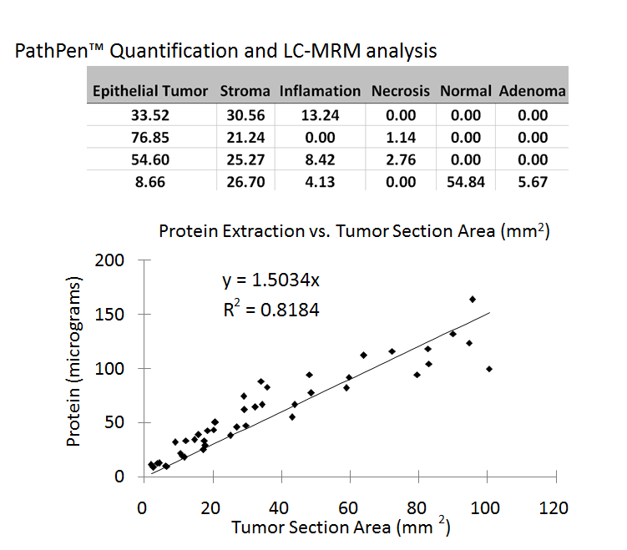

Table 1. is the competent breakdown of area of each segment of both the tumor and microenvironment for a subset of specimens. The segmentation was determined by a pathologist trained image analysis algorithm.

Figure 1. is the complete sample set of colon cancer cases plotting the tumor section area (as determined in the table above) against the micrograms of protein extracted by MS/MS. This shows a correlation between the target protein and the actual tumor content of the sample and can be compared to the same protein measurement for a whole specimen (not shown).

Unfortunately, it is difficult to isolate the tumor from its microenvironment which often extends into the tumor region like fingers or rivers. The ability to accurately and reliably quantify the area of tumor and/or the area of the microenvironment, as shown in table 1 and figure 1, may prove to be important for accurately investigating the tumor microenvironment in pathology.

However, investigating more than the amount of each tissue type of the tumor and microenvironment in a histological sample can be accomplished using image analysis. A number of aspects of the tumor microenvironment on a slide may be quantified by measuring the distribution of areas in the tumor and microenvironment (e.g. heterogeneity) as depicted in figure 2 [Juntilla 2013].

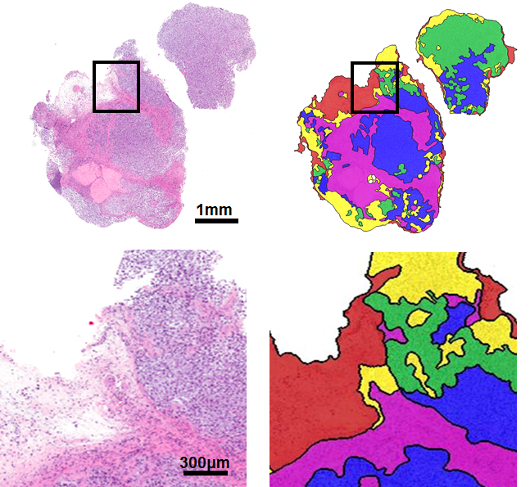

Figure 2. Demonstrates at low (top) and high (bottom) magnification of automated segmentation of tumor and tumor microenvironment regions which can be quantitatively evaluated for distribution or other features (e.g. Ripley’s K or Moran’s I measurements). The masks overlay areas of necrosis (yellow), partial nercrosis (green), viable tumor (blue), stroma (purple) and adipose tissue (red).

Additionally, we can use image analysis to measure other important aspects of the tumor microenvironment. Examples include, the use of pattern recognition image analysis to quantify tumor necrosis in tumor sections. [Lloyd 2014] and the combined use of digital pathology, image analysis and immunoscore metrics to measure the immunological response to a disease (see figure 3) [Anitei 2014, Messina 2012].

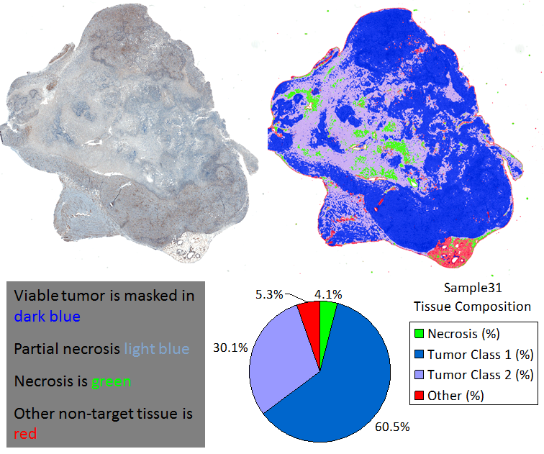

Figure 3. shows the tumor volume in dark blue and the partial and complete necrosis regions in light blue and green, respectively. Other tissue (e.g. adipose) is in red. This allows samples to be compared quantitatively for necrosis or other tumor microenvironmental features with exquisite detail.

Finally, brightfield images provide features within the H&E such as distribution of histocytes or arrangement of stromal fibers, as well as IHC stained features including the number of inflammatory cells (i.e. CD8), number of vessels (i.e. CD31 or CD34), metabolic features such as hypoxia stained by HIF1a, or glucose use or transport by GLUT1 staining, . Together, these brightfield stain applications when coupled with image analysis provide insight into the evaluation of the tumor microenvironment and may in turn be extremely valuable for diagnosis, prognosis and prediction of therapy [Kayser 2010; Sarode 2011; Helm 2009].

1. **Fluorescent Microscopy to Evaluate the Tumor Microenvironment**

In addition to the standard diagnostic brightfield stains, samples may be stained with fluorescent markers that identify specific tumor characteristics. This type sample prep requires different instruments to excite and capture the emission of fluorescence markers such as fluorescent, confocal or super-resolution microscopes. While these instruments represent broad categories of technologies, they each provide unique data to interrogate the tumor microenvironment. Key benefits of fluorescent microcopy include label specificity and the ability to multiplex multiple labels [Bradford 2004].

For example, while it has been shown that vascular measurements of the tumor microenvironment correlate with estrogen receptor status [Lloyd 2014], the ability to specifically label vessels while minimizing non-specific binding remains a significant challenge using brightfield microscopy alone. Furthermore, the ability to use spectral unmixing to determine the localization of brightfield stains introducing additional challenges including dedicated hardware [Levenson 2003]. By contrast, utilizing fluorescence based microscopy allows investigators to label multiple aspects of a single sample with enhanced specificity and verify the results simultaneously. Therefore the vascularity mentioned above can be analyzed simultaneously with ER on the tumor (or any) cells. The number of vessels, size of the vessels and lumens, the distance to ER positive or negative tumor cells or any number of additional metrics may be quantified and studied using image analysis [Peng 2011].

Confocal microscopy enables fluorescently tagged samples to be observed with even more precision. With confocal microscopy investigators can see small targets (i.e. proteins, receptors) with exquisite depth specificity. In other words, two proteins may appear to be in a single location but one may be deeper in a cell that the other. The Z plane specificity provided by confocal microscopy allows researchers to overcome this challenge [Egeblad 2008]. Image analysis is used to identify, segment, count and determine the localization of these targets which can provide information to the investigator about the location and molecular status of the tumor microenvironment as it relates to the tumor itself (see figure 4). For example, the heterogeneity of the tumor microenvironment may contribute to the ability of a tumor to grow or progress [Rojo 2010; Faratian 2011]. This may be observed at a protein level by investigating the molecular differences in different areas of the tumor microenvironment with higher X, Y and Z plane specificity. Finally, super-resolution, as the name implies, is a technique to identify and capture the smallest targets to be captured digitally and measured by image analysis techniques to provide investigators with even finer information about the cells which directly interact with the cancer of study [Chien 2013].

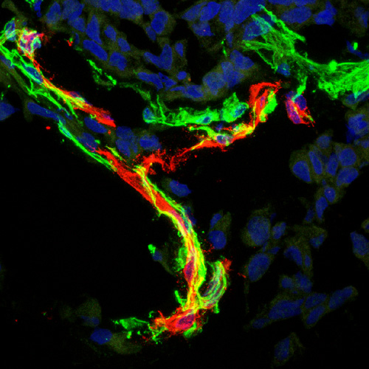 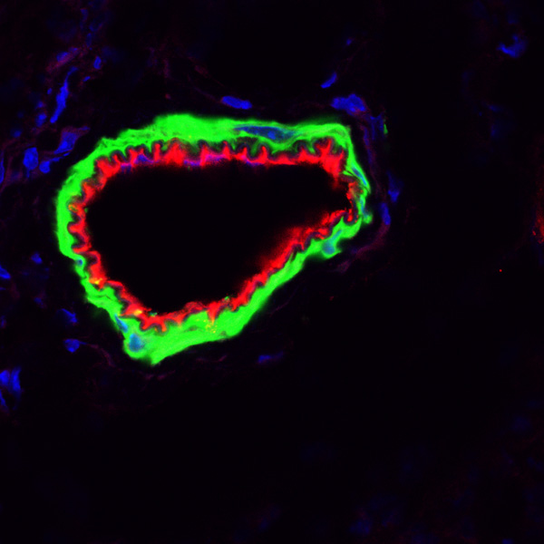

Figure 4. shows two examples of murine prostate tumor nuclei stained with DAPI in blue and two vascular related cell markers for pericytes in green and basal lamina in red. These 3 independent channels were acquired sequentially, minimizing crosstalk between the fluorophores ensuring specificity for each target.

1. **Second Harmonic Generation to Evaluate the Tumor Microenvironment**

Second harmonic generation (SHG) is a label-free technique which enables imaging of specific tissue types, including collagen [Uchugonova 2013]. The process itself is a nonlinear optical image acquisition method. In SHG, photons with the same frequency come into contact with biological material and are effectively doubled which also gives SHG the moniker, frequency doubling. When this doubling occurs, the result is photons with twice the frequency and half the wavelength of the original photon, which are emitted and may be captured [Oka 1990].

Collagen is a principle target of SHG and also prevalent in the tumor microenvironment of many diseases and may be involved in tumor progression [Provenzano 2009]. The ability to analyze the differences in collagen layer thickness and/ or arrangement is increasingly becoming a scientific area of interest in the study of the tumor microenvironment [Iyengar 2005]. An example includes the progression of ductal carcinoma in situ to invasive cancer (see figure 4).

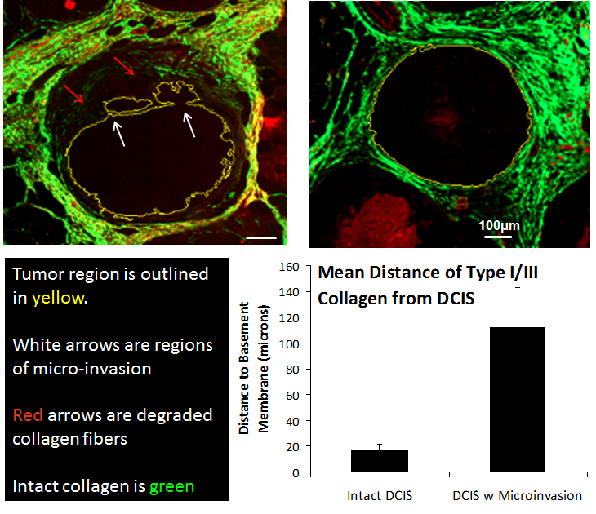Figure 5. In this figure the tumor regions (top) are encircled in the thin yellow line. The microenvironment is imaged with SHG and the shown result on the left illustrates the lack of collagen (red arrows) remaining near a microinvasion site (white arrows) as compared to a complete and intact basement membrane. In the bottom right 20 intact DCIS lesions and 20 DCIS regions with microinvasion were evaluated. The graph depicts the mean distance of the collagen fibers identified by SHG (I/III) to be statistically much further from the basement membrane in microinvasive samples indicating a notable relationship between collagen presence and microinvasion.

1. **Conclusion**

Image analysis has been increasingly providing new avenues for repeatable and quantifiable study of histiocytic sections of tumor. A more rapid and accurate interrogation of the tumor microenvironment of digital and whole slide images will enable the extraction of mathematical values from images which can be used to study and model these interactions. Image analysis allows pathologists to now extend beyond the tumor itself and now incorporate study of the tumor microenvironment. In fact, investigators are now looking to other fields of image analysis, including landscape ecology (Lloyd 2015), to help provide metrics and measures of the tumor and its microenvironment to investigate cancer from a new perspective.

**References**

Amat-Roldan, Ivan, et al. "Fast image analysis in polarization SHG microscopy." Optics express 18.16 (2010): 17209-17219.

Anderson, Alexander, Chaplain Mark, and Katarzyna Rejniak, eds. Single-cell-based models in biology and medicine. Birkhauser-Verlag, Mathematics and Bioscisnce in Interaction (MBI) series, 2007.

Anitei, Maria-Gabriela, et al. "Prognostic and Predictive Values of the Immunoscore in Patients with Rectal Cancer." Clinical Cancer Research 20.7 (2014): 1891-1899.

Beck, Andrew H., et al. "Systematic analysis of breast cancer morphology uncovers stromal features associated with survival." Science translational medicine 3, no. 108 (2011): 108ra113-108ra113.

Ben-Baruch, A. "Host microenvironment in breast cancer development: Inflammatory cells, cytokines and chemokines in breast cancer progression-reciprocal tumor–microenvironment interactions." Breast cancer research 5.1 (2002): 31.

Bradford, Jolene A., et al. "Fluorescence‐intensity multiplexing: Simultaneous seven‐marker, two‐color immunophenotyping using flow cytometry." Cytometry Part A 61.2 (2004): 142-152.

Chien, Miao-Ping, et al. "Enzyme-directed assembly of nanoparticles in tumors monitored by in vivo whole animal imaging and ex vivo super-resolution fluorescence imaging." Journal of the American Chemical Society 135.50 (2013): 18710-18713.

Deepak, Rajasekharan Usha, et al. "Computer Assisted Pap Smear Analyser for Cervical Cancer Screening using Quantitative Microscopy." Journal of Cytology & Histology 2015 (2015).

Dvorak, Harold F., et al. "Tumor microenvironment and progression." Journal of surgical oncology 103.6 (2011): 468-474.

Egeblad, Mikala, et al. "Visualizing stromal cell dynamics in different tumor microenvironments by spinning disk confocal microscopy." Disease models & mechanisms 1.2-3 (2008): 155-167.

Estrella, Veronica, et al. "Acidity generated by the tumor microenvironment drives local invasion." Cancer research 73.5 (2013): 1524-1535.

Faratian, Dana, et al. "Heterogeneity mapping of protein expression in tumors using quantitative immunofluorescence." Journal of visualized experiments: JoVE 56 (2011).

Glatz, Katharina, Bobbi Pritt, Dieter Glatz, Arndt Hartmann, Michael J. O’Brien, and Hagen Blaszyk. "A multinational, internet-based assessment of observer variability in the diagnosis of serrated colorectal polyps." American journal of clinical pathology 127, no. 6 (2007): 938-945.

Gurcan, Metin N., et al. "Histopathological image analysis: A review." Biomedical Engineering, IEEE Reviews in 2 (2009): 147-171.

Helm, J., Centeno, B. A., Coppola, D., Melis, M., Lloyd, M., Park, J. Y., ... & Malafa, M. P. (2009). Histologic characteristics enhance predictive value of American Joint Committee on Cancer staging in resectable pancreas cancer. Cancer, 115(18), 4080-4089.

Iyengar, Puneeth, et al. "Adipocyte-derived collagen VI affects early mammary tumor progression in vivo, demonstrating a critical interaction in the tumor/stroma microenvironment." Journal of Clinical Investigation 115.5 (2005): 1163.

Junttila, Melissa R., and Frederic J. de Sauvage. "Influence of tumour micro-environment heterogeneity on therapeutic response." Nature 501.7467 (2013): 346-354.

Kayser, Klaus, et al. "AI (artificial intelligence) in histopathology--from image analysis to automated diagnosis." Folia Histochemica et Cytobiologica 47.3 (2010): 355-354.

Karabulut, A., Jesper Reibel, Marianne Hamilton Therkildsen, Finn Prætorius, H. W. Nielsen, and Erik Dabelsteen. "Observer variability in the histologic assessment of oral premalignant lesions." Journal of oral pathology & medicine 24, no. 5 (1995): 198-200.

Kenny, Paraic A., Genee Y. Lee, and Mina J. Bissell. "Targeting the tumor microenvironment." Frontiers in bioscience: a journal and virtual library 12 (2007): 3468.

Levenson, Richard M., Paul J. Cronin, and Kirill K. Pankratov. "Spectral imaging for brightfield microscopy." Biomedical Optics 2003. International Society for Optics and Photonics, 2003.

Li, Hanchen, Xueli Fan, and JeanMarie Houghton. "Tumor microenvironment: the role of the tumor stroma in cancer." Journal of cellular biochemistry 101.4 (2007): 805-815.

Lloyd, Mark C., et al. "Using image analysis as a tool for assessment of prognostic and predictive biomarkers for breast cancer: How reliable is it?." Journal of pathology informatics 1 (2010).

Lloyd, Mark C., Khalid O. Alfarouk, Daniel Verduzco, Marilyn M. Bui, Robert J. Gillies, Muntaser E. Ibrahim, Joel S. Brown, and Robert A. Gatenby. "Vascular measurements correlate with estrogen receptor status." BMC cancer 14, no. 1 (2014): 279.

Lloyd, M. C., Rejniak, K. A., Brown, J. S., Gatenby, R. A., Minor, E. S., & Bui, M. M. (2015). Pathology to Enhance Precision Medicine in Oncology: Lessons From Landscape Ecology. Advances in anatomic pathology, 22(4), 267-272.

Mass, Robert D., et al. "Evaluation of clinical outcomes according to HER2 detection by fluorescence in situ hybridization in women with metastatic breast cancer treated with trastuzumab." Clinical breast cancer 6.3 (2005): 240-246.

Mavaddat, Nasim, et al. "Research article Incorporating tumour pathology information into breast cancer risk prediction algorithms." (2010).

McInerney, Tim, and Demetri Terzopoulos. "Deformable models in medical image analysis: a survey." Medical image analysis 1.2 (1996): 91-108.

Messina, Jane L., et al. "12-Chemokine gene signature identifies lymph node-like structures in melanoma: potential for patient selection for immunotherapy?." Scientific reports 2 (2012).

Nyberg, Pia, Tuula Salo, and Raghu Kalluri. "Tumor microenvironment and angiogenesis." Frontiers in bioscience: a journal and virtual library 13 (2007): 6537-6553.

Ohashi, A., et al. "Quantitative analysis of the microvascular architecture observed on magnification endoscopy in cancerous and benign gastric lesions." Endoscopy 37.12 (2005): 1215-1219.

Oka, Michio. "Second harmonic generation." U.S. Patent No. 4,910,740. 20 Mar. 1990.

Peng, Chun-Wei, et al. "Patterns of cancer invasion revealed by QDs-based quantitative multiplexed imaging of tumor microenvironment." *Biomaterials*32.11 (2011): 2907-2917.

Provenzano, Paolo P., Kevin W. Eliceiri, and Patricia J. Keely. "Multiphoton microscopy and fluorescence lifetime imaging microscopy (FLIM) to monitor metastasis and the tumor microenvironment." Clinical & experimental metastasis 26.4 (2009): 357-370.

Rejniak, K. A. "Homeostatic imbalance in epithelial ducts and its role in carcinogenesis", Scientifica, (2012): 132978.

Robertson, A. J., J. M. Anderson, J. Swanson Beck, R. A. Burnett, S. R. Howatson, F. D. Lee, A. M. Lessells, K. M. McLaren, S. M. Moss, and J. G. Simpson. "Observer variability in histopathological reporting of cervical biopsy specimens." Journal of clinical pathology 42, no. 3 (1989): 231-238.

Rojo, Marcial García, Gloria Bueno, and Janina Slodkowska. "Review of imaging solutions for integrated quantitative immunohistochemistry in the Pathology daily practice." Folia histochemica et cytobiologica 47.3 (2010): 349-348.

Sarode, Venetia R., et al. "A comparative analysis of biomarker expression and molecular subtypes of pure ductal carcinoma in situ and invasive breast carcinoma by image analysis: relationship of the subtypes with histologic grade, Ki67, p53 overexpression, and DNA ploidy." International journal of breast cancer 2011 (2011).

Schindewolf, Thomas, et al. "Evaluation of different image acquisition techniques for a computer vision system in the diagnosis of malignant melanoma." Journal of the American Academy of Dermatology 31.1 (1994): 33-41.

Serra, Jean. Image analysis and mathematical morphology, v. 1. Academic press, 1982.

Song, Nan, Tao LI, and Xue-Min ZHANG. "Immune Cells in Tumor Microenvironment." Progress in Biochemistry and Biophysics 41.10 (2014): 1075-1084.

Uchugonova, Aisada, et al. "Multiphoton tomography visualizes collagen fibers in the tumor microenvironment that maintain cancer‐cell anchorage and shape." Journal of cellular biochemistry 114.1 (2013): 99-102.

Wetzels, R. H., et al. "Detection of basement membrane components and basal cell keratin 14 in noninvasive and invasive carcinomas of the breast." The American journal of pathology 134.3 (1989): 571.